

**E-Commerce Dashboard**

Wireframe Documentation



# Dashboard

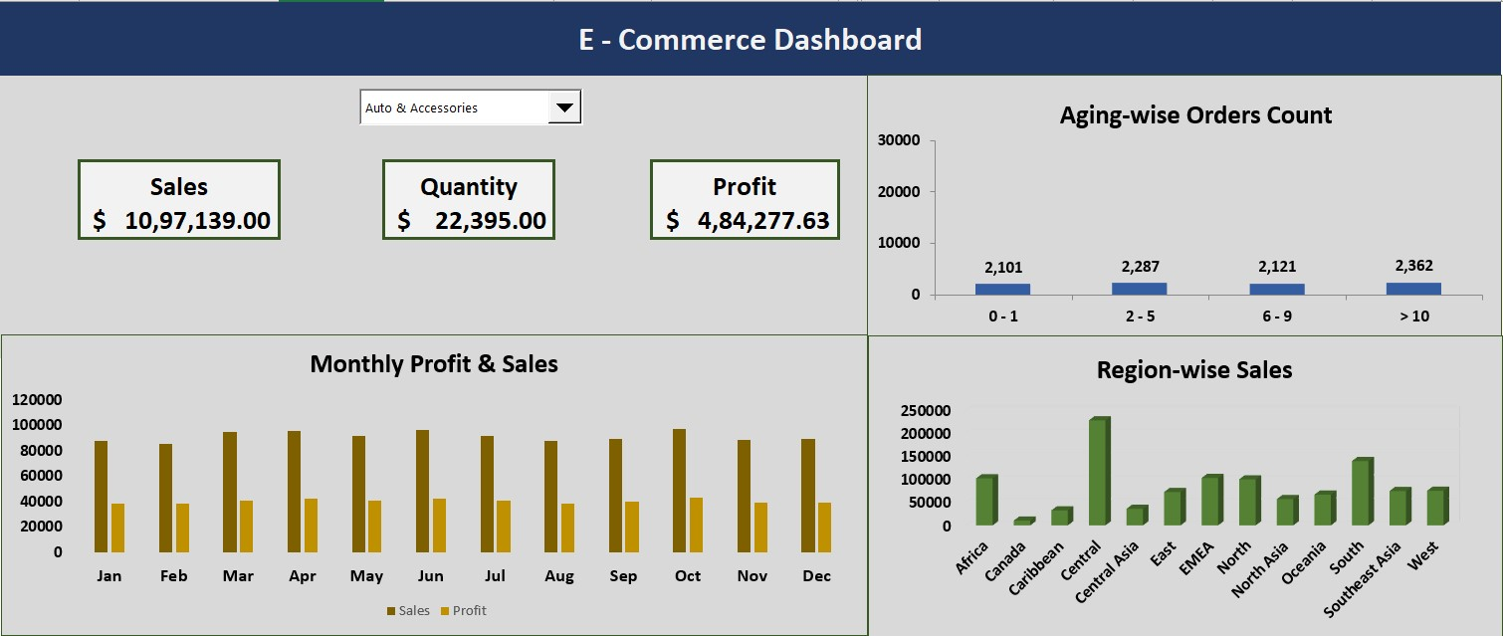



1. Monthly Sales and Profits Trend Chart:

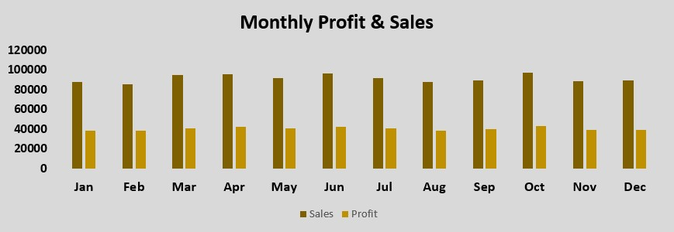

1. Region-wise Sales Distribution Chart:

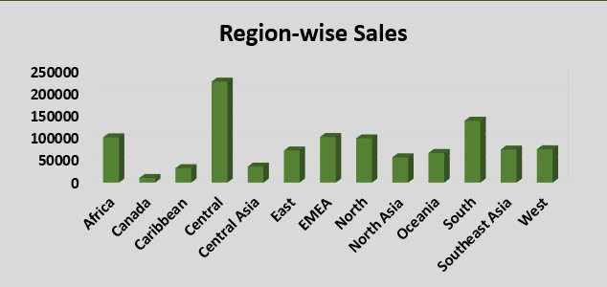



1. User Control Combo Box for Product Category:



1. Aging-wise Orders Count Chart:

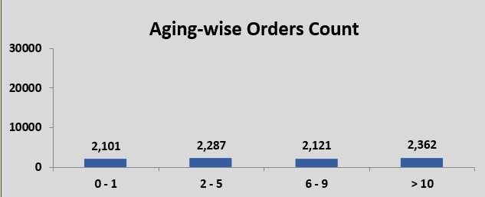



1. Different Metrics:

